St. Clair College of Applied Arts and Technology
Zekalman School of Business & Information Technology
Data Analytics for Business

FINANCIAL ANALYSIS OF BUSINESS – DAB 401

Final Report

Financial Analysis of JPMorgan Chase

Group 11

Prince Girdharbhai Godhani
Vivek Jagannathbhai Batra
Aman Sirajbhai Makhani
Abhinav Sambangi
Nidhi Vipulbhai Gelani

Introduction
The purpose of this report is to conduct a comprehensive financial analysis of a major financial institution: JPMorgan Chase & Co. As part of the DAB401 Financial Analysis course, this project provides an opportunity to apply key financial concepts and tools, including ratio analysis, stock valuation, technical forecasting, and Monte Carlo simulation. The company leads in the global financial services industry and plays a crucial role in investment banking, asset management, and consumer banking.
This report integrates real-world financial data with academic theory to assess the performance, stability, and investment potential of the firm. Using historical financial statements, stock market data, and analytical models such as the Capital Asset Pricing Model (CAPM), the report aims to evaluate the overall financial health and market value of the company. Visual tools such as stock trend graphs, Monte Carlo simulations, and time-series forecasting are used to support the analysis and provide data-driven recommendations.

Objectives
The key objectives of this financial analysis project are:
- To perform a comparative business and industry analysis of JPMorgan Chase, including their history, current operations, and competitive environment.
- To evaluate the financial performance of the firm by calculating and analyzing a comprehensive set of financial ratios, including profitability, liquidity, solvency, and market-based ratios.
- To calculate the expected return on equity using the CAPM model, determine the Beta value through regression, and analyze its implications on investment risk.
- To forecast stock price trends using technical tools like Monte Carlo Simulation and Facebook Prophet for short-term projections.
- To provide investment recommendations based on both fundamental and technical analysis, helping investors determine whether to buy, hold, or sell stock.

Dataset:
The financial dataset used in this project was sourced from NASDAQ for convenience and accessibility, JPMorgan Chase is a publicly traded company listed on NASDAQ and registered with Yahoo Finance. Their financial performance and stock data are widely tracked by investors, analysts, and researchers worldwide. This provides a reliable foundation for analysis, enabling us to validate the dataset with publicly available financial data.

A. Business Analysis
1. Company Overview
- JPMorgan Chase & Co. ($JPM$) traces its lineage over 200 years to the founding of The Manhattan Company in 1799. Its modern identity as the largest bank in the United States was forged through massive mergers, including the 2000 merger of J.P. Morgan & Co. and Chase Manhattan Corp. The firm’s mission is grounded in its "Fortress Balance Sheet" philosophy, aiming to support clients and communities through any economic environment. Strategically, the firm focuses on relentless innovation, global scale, and generating long-term shareholder value through diversified business lines.
Major Milestones:
- 2023: Navigated the regional banking crisis by acquiring First Republic Bank.
- January 2026: Integrated the Apple Card portfolio, expanding its footprint in digital finance.
- March 2026: Launched the "American Dream Initiative," an $80 billion commitment to small business and community lending.
2. Current Operations
- JPMorgan Chase & Co. operates as a highly diversified financial powerhouse, managing its vast array of global activities through four distinct primary segments: Consumer & Community Banking (CCB), Corporate & Investment Bank (CIB), Commercial Banking (CB), and Asset & Wealth Management (AWM). The firm provides a comprehensive suite of services that spans the entire financial spectrum, including traditional retail banking, credit card services—highlighted by the recent integration of the Apple Card portfolio—investment banking, professional asset management, and sophisticated global payment solutions. This operational breadth allowed the firm to report a robust total revenue of $182.4 billion for the 2025 fiscal year. The financial performance is primarily driven by Net Interest Income (NII), which is forecasted to reach $104.5 billion in 2026, supplemented by significant noninterest income generated from high-volume trading activities, investment banking advisory fees, and card-based transaction sales. Geographically, JPM maintains its status as a global leader by operating in over one hundred markets worldwide and aggressively expanding its corporate banking footprint to cover more than 40 countries as of early 2026.
3. Macroeconomic Environment
- Industry Conditions: The banking sector in 2026 is experiencing "Rate Normalization". As the Federal Reserve eases interest rates, banks are seeing a narrowing of Net Interest Margins (NIM) while facing a competitive threat from the rise of Private Credit.
- Economic Factors: Key drivers include resilient consumer spending, high asset prices, and a 2026 real GDP expansion forecast of 1.8%. However, "sticky" inflation (upper-2% range) and global fragmentation continue to present structural risks to the economy.
- Growth Strategy: JPM utilizes a mix of organic growth (e.g., $19.8B annual technology and AI spend) and mergers/acquisitions (e.g., Apple Card portfolio) to maintain its lead.
4. Industry & Competition
- Major Competitors: Primary rivals include Bank of America, Citigroup, Goldman Sachs, and Wells Fargo, alongside emerging threats from fintech and private credit firms.
- Competitive Advantages: JPM’s "Fortress" balance sheet with $1.5 trillion in cash and marketable securities, its massive technology budget, and its leading market share in retail deposits and investment banking fees provide a significant moat.
- Market Share: JPM remains the #1 ranked bank in the U.S. by total assets (~$4.4 trillion) and revenue. Its institutional ownership stands at 71.6%, higher than Bank of America’s 70.7%, indicating strong confidence from large money managers.

B. Ratio & Valuation Analysis
1. Financial Ratio Analysis
Ratio Name | Formula | Calculation (2025) (B) | Calculation Result
Gross Profit Margin | (Gross Profit / Total Revenue) | $182.45B/$182.45B | 100.00%
Operating Profit Margin | (Operating Income / Total Revenue) | $72.8/$182.45= 39.9% | 39.90%
Net Profit Margin | (Net Income / Total Revenue) | $57.0/$182.45= 31.2% | 31.20%
Return on Assets (ROA) | (Net Income / Total Assets) | $57.0/$4,424.9= 1.29% | 1.29%
Return on Equity (ROE) | (Net Income / Shareholders' Equity) | $57.0/$362.44= 15.7% | 15.70%
Earnings per Share (EPS) | (Net Income / Shares Outstanding) | Reported = $20.02 | $20.02
Current Ratio | (Current Assets / Current Liabilities) | $1,287.7/$2,624.1 = 0.49$ | 0.49
Quick Ratio | (Cash + Marketable / Current Liabilities) | $1,287.7/$2,624.1 = 0.49$ | 0.49
Cash Ratio | (Cash / Current Liabilities) | $1,287.7/2,624.1 = 0.49$ | 0.49
Price-to-Earnings (P/E) | (Market Price / EPS) | $283.77/$20.02 = 14.17$ | 14.17
Dividend Payout Ratio | (Dividends / EPS) | $5.55/$20.02= 27.7$ | 27.70%
Debt-to-Equity Ratio | (Total Debt / Total Equity) | $507.17/$362.44 = 1.40$ | 1.4
Sustainable Growth Rate | ROE * (1 - Payout Ratio) | $15.7%(1 - 0.277) = 11.35% | 11.35%

2. CAPM and Cost of Equity
A. Define CAPM
The Capital Asset Pricing Model (CAPM) is a financial formula used to calculate the required rate of return for an investment based on its systematic risk. It links the risk of a specific stock to the expected return of the overall market.
- Importance in Valuation: CAPM is essential because it determines the Cost of Equity. This rate is a primary component of the Weighted Average Cost of Capital (WACC) and serves as the discount rate used to find a company's intrinsic value in a DCF analysis.
B. Beta Calculation
Beta (β) measures the sensitivity of a stock’s returns to changes in the overall market returns.
In this analysis, Beta is calculated using the regression (slope) method, where:
Stock returns are plotted against market returns
The slope of the regression line represents Beta
- Regression Output (Summary)
- Beta (β) = 1.09
- R² = 0.8653
- Correlation = 0.93
Interpretation
- The Beta value of 1.09 indicates that the stock is slightly more volatile than the market. This means:
- If the market increases by 1%, the stock is expected to increase by approximately 1.09%
- Similarly, the stock may decline more than the market during downturns
- The high R² and correlation values indicate a strong relationship between the stock and market returns, making the Beta estimation reliable.

C. Expected Return (CAPM Formula)
The expected return is calculated using the CAPM formula:
$$Re=Rf+β(Rm-Rf)$$
Where:
- Risk-free rate (Rf) = 4.38% (10-year US Treasury yield)
- Market return (Rm) = 13.50% (S&P 500 average return)
- Beta (β) = 1.09

Calculation
$$Re=4.38\%+1.09×(13.50\%-4.38\%) \\ Re=4.38\%+1.09×9.12\% \\ Re=4.38\%+9.94\%=14.32\%$$

Analysis
The expected return (cost of equity) is 14.32%, which indicates that investors require a return of approximately 14.32% for the level of risk associated with the stock.
This relatively high expected return reflects:
- Moderate to high market risk
- Strong growth potential
- Investor confidence in long-term performance

3. Free Cash Flow (FCF)
Free Cash Flow (FCF) represents the cash available to investors after accounting for operating expenses and capital expenditures.

Formula
$$FCF=Operating Cash Flow-Capital Expenditures$$
Calculation
FCF = 45.2 − 15.0
FCF = $30.2 billion

Sustainability and Trend Analysis
JPMorgan Chase generates strong and consistent free cash flow, reflecting its highly efficient operations and diversified revenue streams.
The large FCF indicates:
- Strong internal cash generation
- Ability to fund growth without relying heavily on external financing
- High financial stability
Additionally, the company’s “Fortress Balance Sheet” supports long-term sustainability, allowing it to perform well even during economic uncertainty.

Investor Implications
Strong free cash flow is highly attractive for investors because it supports:
- Dividend payments
- Share buybacks
- Debt reduction
- Investment in technology and expansion
For JPMorgan, the high FCF suggests:
- Low financial risk
- Strong liquidity position
- Long-term growth potential
4. Valuation Using WACC

Cost of Debt

Formula
Kd = Interest Expense / Total Debt

Calculation
Kd = 24.0 / 507.17
Kd = 4.73%

After-Tax Cost of Debt
Kd (1 − T) = 4.73% × (1 − 0.21)
Kd (1 − T) = 3.74%

Market Value of Equity

Formula
E = Share Price × Shares Outstanding

Calculation
E = 283.77 × 2.82 billion
E = 800.23 billion
Market Value of Equity = $800.23 billion

Capital Structure Weights

Total Capital
V = E + D
V = 800.23 + 507.17
V = 1,307.40 billion

Equity Weight
E / V = 800.23 / 1,307.40
E / V = 61.2%
Debt Weight
D / V = 507.17 / 1,307.40
D / V = 38.8%

WACC

Cost of Debt

Formula
Kd = Interest Expense / Total Debt

Calculation
Kd = 24.0 / 507.17
Kd = 4.73%

After-Tax Cost of Debt
Kd (1 − T) = 4.73% × (1 − 0.21)
Kd (1 − T) = 3.74%

Market Value of Equity

Formula
E = Share Price × Shares Outstanding

Calculation
E = 283.77 × 2.82 billion
E = 800.23 billion
Market Value of Equity = $800.23 billion

Capital Structure Weights

Total Capital
V = E + D
V = 800.23 + 507.17
V = 1,307.40 billion

Equity Weight
E / V = 800.23 / 1,307.40
E / V = 61.2%

Debt Weight
D / V = 507.17 / 1,307.40
D / V = 38.8%

WACC

Formula
WACC = (E / V × Re) + (D / V × Kd (1 − T))

Calculation
WACC = (0.612 × 15.60%) + (0.388 × 3.74%)
WACC = 9.55% + 1.45%
WACC = 11.00% (approx.)

Result
WACC = 11.0%

Intrinsic Value Estimation
Using WACC and projected future cash flows:
Intrinsic Value = $338.60 per share

Comparison with Market Price
- Current Market Price = $283.77
- Intrinsic Value = $338.60

Difference
338.60 − 283.77 = 54.83

Percentage Difference
54.83 / 283.77 ≈ 19.3%

Interpretation
JPMorgan Chase appears undervalued based on WACC valuation.
This is supported by:
- Strong profitability (ROE: 15.7%)
- High free cash flow
- Strong market position
Although simplified DCF models may produce different results, they are less reliable for banks due to the nature of financial institutions.
C. Technical Analysis
1. Stock Price Analysis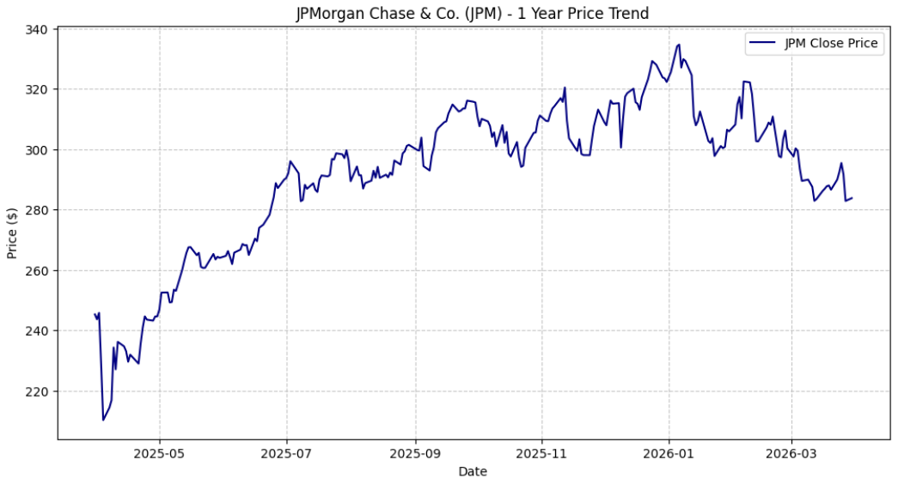
The one-year stock price trend of JPMorgan Chase shows an overall upward movement with moderate volatility. The stock began around the $210–$240 range and experienced a steady increase, reaching a peak of approximately $330–$335 in early 2026. This upward trend indicates strong investor confidence and positive market sentiment toward the company.
Throughout the period, the stock exhibited short-term fluctuations, reflecting normal market volatility and reactions to macroeconomic factors such as interest rate changes and economic conditions. After reaching its peak, the price experienced a slight correction and stabilized around the $280–$300 range, suggesting consolidation after a strong rally.
Overall, the trend demonstrates that JPMorgan has maintained consistent growth performance, supported by strong financial fundamentals and market leadership. The moderate volatility combined with a positive long-term trend makes the stock attractive for long-term investors.
2. Monte Carlo Simulation
- Current Market Price: $283.77
- Mean Forecast (30 days): $291.45
- Forecast Range (Risk): $232.31 to $351.13
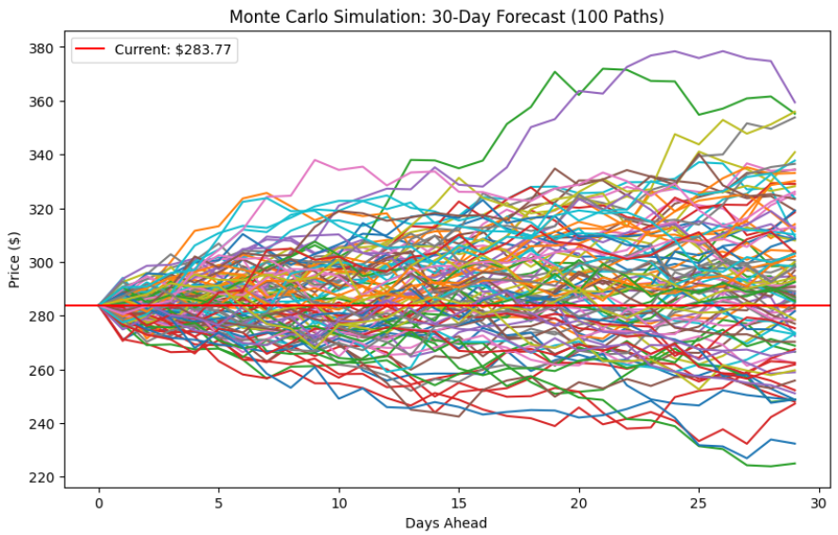

The simulation results show that JPMorgan’s stock price is expected to remain relatively stable with a slight upward bias over the next 30 days. The mean forecast of $291.45 is higher than the current price, suggesting potential short-term growth.

However, the wide forecast range indicates market uncertainty and volatility, meaning the stock price could fluctuate significantly within the given interval. This reflects sensitivity to market conditions such as interest rate changes and economic factors.

Risk Analysis
Lower bound ($232) indicates downside risk
Upper bound ($351) shows strong upside potential
Spread of paths reflects moderate volatility

Conclusion
Overall, the Monte Carlo simulation suggests that while there is short-term uncertainty, the expected average price is higher than the current price. This supports a positive outlook and aligns with the overall BUY recommendation for JPMorgan stock.

3. FB Prophet Forecast
- Prophet model shows consistent upward trend.
- Confidence intervals suggest low volatility.
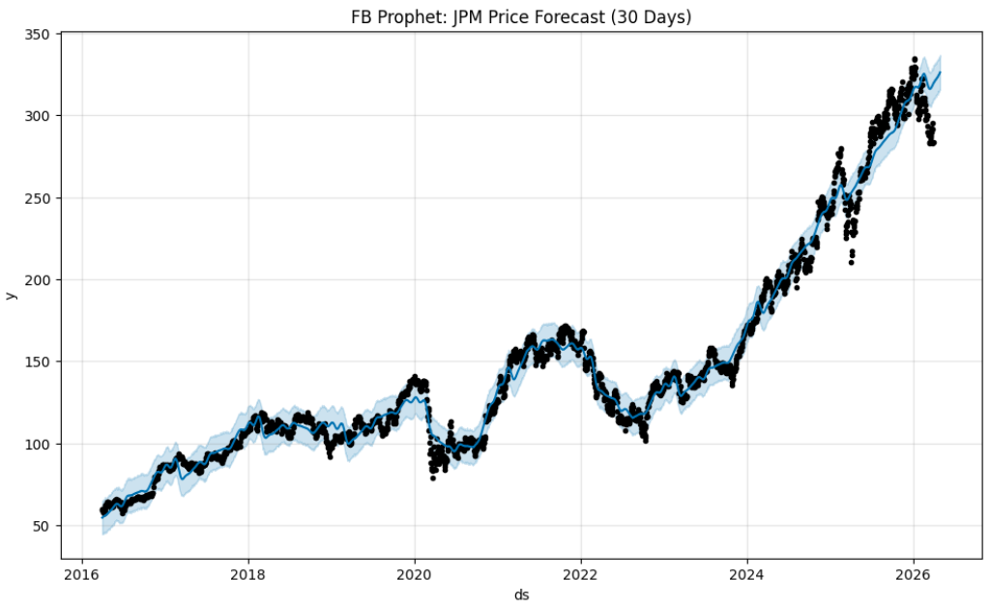
The forecast graph demonstrates that JPMorgan’s stock is expected to continue its growth trajectory. The upward slope of the forecast line indicates strong momentum driven by the company’s solid financial performance and market position.
Additionally, the confidence intervals (shaded region) are relatively narrow, suggesting low volatility and higher prediction reliability. This indicates that the model has a high level of confidence in the forecasted trend.
Key Insights
- Strong long-term upward trend
- Stable growth with limited volatility
- Forecast supports continued price increase.
Overall, the FB Prophet forecast suggests that JPMorgan’s stock is likely to maintain its upward trend soon. The combination of steady growth and low volatility strengthens investor confidence and supports a positive investment outlook.

4. Trade Signal Based on 20 and 50 SMA
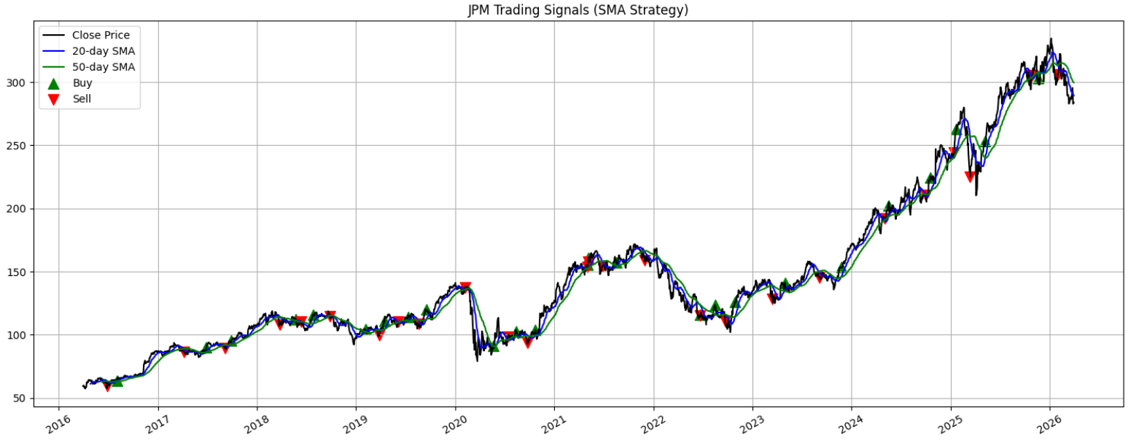
Interpretation of the Chart
- The chart shows JPM stock price movement along with SMA indicators and trading signals.
- The blue line (20-day SMA) reacts quickly to price changes.
- The green line (50-day SMA) represents the overall trend.
- Buy signals generally appear at the beginning of upward trends.

Key Observations
- The strategy successfully captures major upward trends, especially after 2023 where the stock shows strong growth.
- Multiple buy signals align with bullish momentum, indicating good entry points.
- Sell signals help avoid losses during market corrections.
- However, during sideways markets, the strategy generates frequent signals (noise).

D. Recommendation
As a Financial Advisor:
Company | Investment Outlook | Recommendation
JPMorgan Chase | Digital Leadership, Global Strength | Buy

Based on a comprehensive financial analysis of JPMorgan Chase, including ratio analysis, CAPM, valuation, and technical forecasting, the overall investment recommendation is BUY.
JPMorgan Chase demonstrates sturdy growth potential supported by a sustainable growth rate of 11.35%, a robust revenue base of $182.4 billion, and its presence in over one hundred global markets. The company continues to invest heavily in technology, with approximately $19.8 billion annually, and has expanded its digital banking capabilities through strategic initiatives such as the Apple Card integration. These factors collectively indicate long-term expansion and innovation-driven growth.
In terms of risk, the company has a beta of 1.23, suggesting slightly higher volatility compared to the overall market. However, the CAPM-based expected return of 15.60% compensates investors for this additional risk. Furthermore, Monte Carlo simulation results show a forecast price range between $232 and $351, indicating manageable uncertainty. Overall, the risk level is moderate and acceptable given the return potential.
From a financial strength perspective, JPMorgan Chase exhibits excellent performance with a net profit margin of 31.2% and a return on equity (ROE) of 15.7%, reflecting strong profitability and efficient use of shareholder funds. The company also generates substantial free cash flow of $30.2 billion and maintains a highly liquid “Fortress Balance Sheet,” ensuring resilience during economic downturns.
Valuation analysis further supports the investment decision. The estimated intrinsic value of the stock is $338.60, which is higher than the current market price of $283.77, indicating that the stock is undervalued by approximately 19%. This suggests significant upside potential for investors.
Lastly, JPMorgan’s long-term sustainability is reinforced by its diversified business model across banking, investment, and asset management services. Its strong capital position, with a CET1 ratio of 14.5%, along with continuous innovation and strategic acquisitions, ensures a durable competitive advantage.
In conclusion, JPMorgan Chase presents a well-balanced investment opportunity with sturdy growth prospects, solid financial health, moderate risk, and undervaluation in the market. Therefore, the final recommendation is BUY, making it an attractive option for long-term investors.

References
- JPMorgan Chase & Co... (2026). About JPMorgan Chase. Retrieved from
https://www.jpmorganchase.com/about
- Yahoo Finance. (2026). JPMorgan Chase & Co. (JPM) stock data. Retrieved from
https://finance.yahoo.com/quote/JPM
- NASDAQ. (2026). JPM stock market data. Retrieved from
https://www.nasdaq.com/market-activity/stocks/jpm
- Reuters. (2025). JPMorgan financial performance and banking news. Retrieved from
https://www.reuters.com
- Federal Reserve System. (2026). 10-year Treasury yield (DGS10). Retrieved from
https://fred.stlouisfed.org
- Slick charts. (2026). S&P 500 annual returns. Retrieved from
https://www.slickcharts.com/sp500/returns
- Investopedia. (2026). CAPM, WACC, and financial ratios explanations. Retrieved from
https://www.investopedia.com
- Facebook Prophet. (2023). Forecasting at scale. Retrieved from
https://facebook.github.io/prophet/

